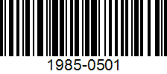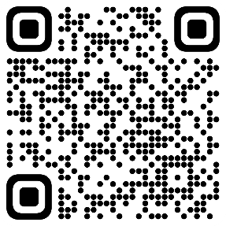Item #1: Headphones

**Gift AID: 171844**

**Price:** £**20**

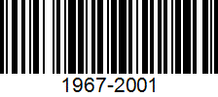Item #2: Jacket

**Gift AID: 290401**

**Price:** £**8**

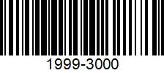Item #3: Child Stroller

**Gift AID: 402376**

**Price:** £**40**